# **OCD PATIENT ANALYSIS REPORT**

# INTRODUCTION :-

OCD (Obsessive-Compulsive Disorder) is a mental health condition where a person experiences :

* Obsessions – unwanted, repetitive, and intrusive thoughts, images or urges such as fear of germs, worry about safety and harm.
* Compulsions – repetitive actions or rituals that someone feels driven to perform to reduce anxiety caused by the obsessions such as excessive cleaning, checking locks repeatedly, arranging things in a particular way.

This dataset is a comprehensive collection of information pertaining to 1500 individuals diagnosed with Obsessive-Compulsive Disorder (OCD). It encompasses a wide range of parameters, providing a detailed insight into the demographic and clinical profiles of these individuals. Included in this dataset are key demographic details such as age, gender, ethnicity, marital status, and education level, offering a comprehensive overview of the sample population. Additionally, clinical information like the date of OCD diagnosis, duration of symptoms, and any previous psychiatric diagnoses are recorded, providing context to the patients' journeys.

The dataset also delves into the specific nature of OCD symptoms, categorizing them into obsession and compulsion types. Severity of these symptoms is assessed using the Yale-Brown Obsessive-Compulsive Scale (Y-BOCS) scores for both obsessions and compulsions. Furthermore, it documents any co-occurring mental health conditions, including depression and anxiety diagnoses.

Notably, the dataset outlines the medications prescribed to patients, offering valuable insights into the treatment approaches employed. It also records whether there is a family history of OCD, shedding light on potential genetic or environmental factors

## Objective :-

The goal of this project is to perform an exploratory data analysis (EDA) on a dataset containing demographic and clinical data of OCD patients. The analysis will focus on understanding the relationships between various demographic factors and clinical outcomes. In this analysis different variables will be analyzed to derive meaningful and useful information from the data set. The dataset which is used in this analysis is  **"OCD Patient Dataset: Demographics & Clinical Data”**

### Tools Used :-

Tools used for Data Cleaning, Exploratory Data Analysis and Visualizations are as follows :–

* Excel
* Microsoft Power BI

## KEY FINDINGS :-

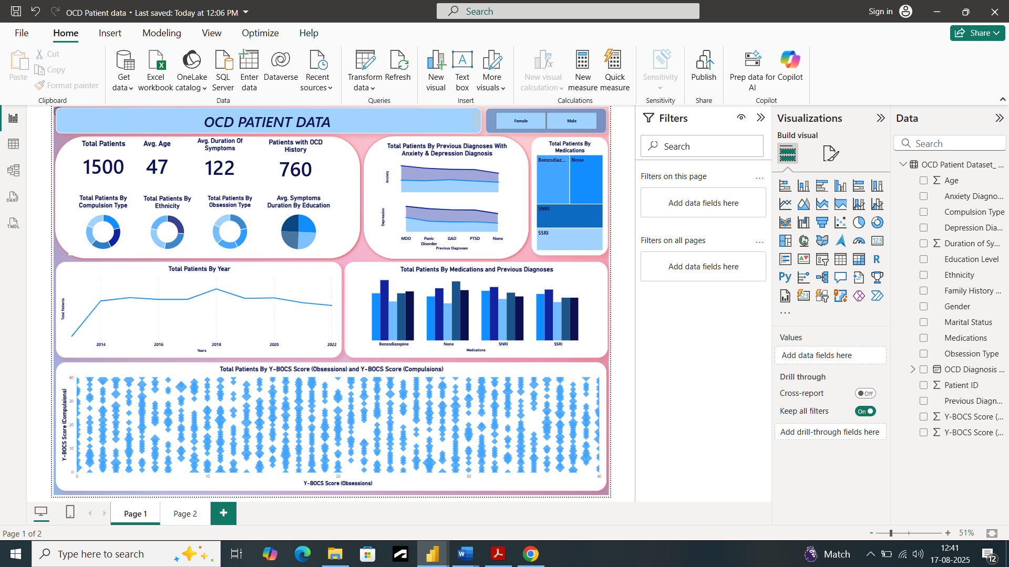

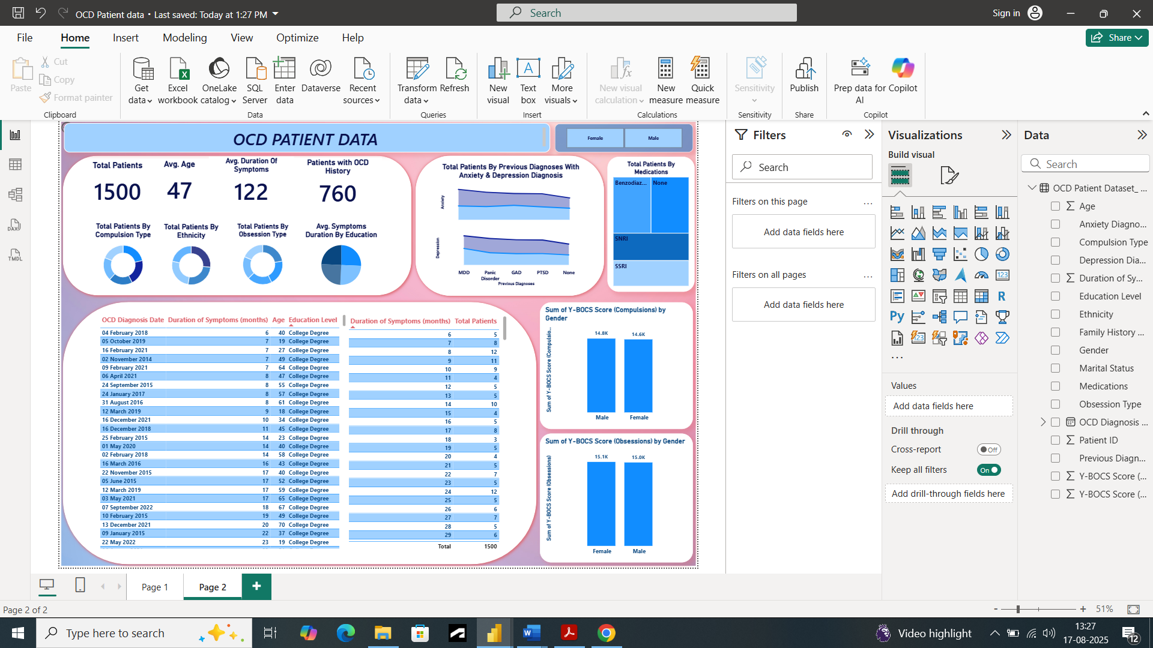

1. There are total of 1500 patients who have been diagnosed with OCD in 8 years from 2013 to 2021.
2. Females are slightly more in number in terms of affected by OCD.
3. Average age of these patients is 47 years. Individuals aged **25-34 years** show the highest prevalence of OCD and Average duration of symptoms is 122 months.
4. There are also 760 patients who have a family history of OCD.
5. There are 321 patients which have diagnosed with ‘Washing’ type of compulsion which is 21.4 % of the total patients distribution by the compulsion type. So, we can say that the most prevailing compulsion is washing while ordering is the least one comprising only 285 patients (19%).
6. There are 398 patients who belongs to ‘Caucasian’ type of ethnicity which is 26.53% of the total patients distribution by the ethnicity. ‘Hispanic’ is also nearby the Caucasian comprising 392 patients. Highest number of patients who have diagnosed with OCD are Caucasians followed by Hispanic while the least diagnosed people are Africans.
7. Most prevailing obsession type is ‘Harm-related’ with 333 patients in 8 years making it 22.3% of overall distribution by obsessions. Hoarding is the least one with 278 patients (18.53%).
8. There are a lot of patients with very high duration of symptoms. Highest duration of symptoms is 240 months and there is only one patient with this much delay of diagnosis. There are 14 patients with 171 months which is the second highest and 13 patients with 167 months and all these patients have education level of some college.
9. Most of the patients who have delayed their diagnosis possess the education level of college degree.
10. Most of the patients have been diagnosed with anxiety and depression. Anxiety and depression seem to frequently co-occur with OCD.
11. Highest number of patients are treated with Benzodiazepine medication and None.
12. Number of patients diagnosis rose significantly in the year 2018 with a slight fall in 2019 and maintained an almost stable state till 2022.
13. The number of patients who have been treated with Benzodiazepine are mostly previously diagnosed with MDD and in case of None medication mostly patients have been previously diagnosed with panic disorder.
14. In case of some patients, Y-BOCS Score (Compulsions) is high, and Y-BOCS Score (Obsessions) is low and vice versa. Females had the highest number of Y-BOCS Score (Obsessions) compared to male. But Males have the highest number of Y-BOCS Score (Compulsions) compared to Female.

## Conclusion :-

In conclusion of this project, we can say that OCD seems to be more predominant in the Female population and Caucasians and with patients who have family history of OCD and previously diagnosed with depression and anxiety. Diagnostic delay is maximum 240 months, and the most preferred medications are Benzodiazepine and None. All these factors cannot be corrected at once or completely but by making little improvements things can be better. Such as:-

* Targeted mental health campaigns can be implemented for females of age between 25-34 years. Encouraging routine mental health screenings for anxiety and OCD symptoms.
* Diagnostic delays should be avoided.
* Addressing the most common symptoms like Washing and harm-related Obsessions. Giving patients psychoeducation.
* Dual-Diagnosis therapies instead of just medication can be promoted to treat anxiety and depression along with.